Lecture 17

**Domain Registration-LIVE-Web Hosting**

We want to host our own website –LIVE

* Webhosting, APACHE + DNS
* 2 sections,
  + ec2 Instance 🡪 we will host out website with LIVE IP
  + .
* 1st section
* **Launch EC2 instance in AWS**
* To check LIVE IP 🡪 $ curl ifconfig.me
* 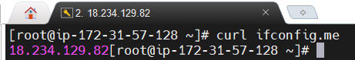
* Update the system $ yum update -y
* Install “httpd” $ yum install httpd-* -y
* $ systemctl start httpd
* $ systemctl enable httpd
* $ yum install telnet 🡪 to check if port is opened
* $telnet 127.0.0.1 80
* 
* $ cd /var/www/htlm
* $ vi index.html 🡪 type some dummy text in this file and save it.
* $  🡪 copy sample conf file for configuration.
* Edit this file. In this location 🡪 $ /etc/httpd/conf.d
* Go to end (container)
* Make these 3 changes
* 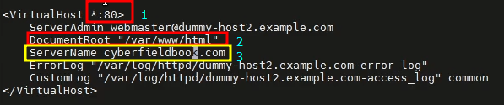
* This domain is already registered.
* Save the file
* $ httpd -t 🡪 to text the file if it is OK or have some errors.
* $ systemctl reload httpd 🡪 reload to run the service with recent changes.
* Now access this webpage from the Public IP of EC@ instance
* In browser httpd://<LiveIP> e.g 54/122/54/167
* Page is not opening.

Troubleshooting

* Try telnet Live IP of EC3 instance on port 80 🡪 $ telbnet <live_IP> 80
* *It is not establishing connection because firewall (SG- Security Group) of EC2 instance is blocking the connection.*
* How to open port in SG on EC2 Instance.
* 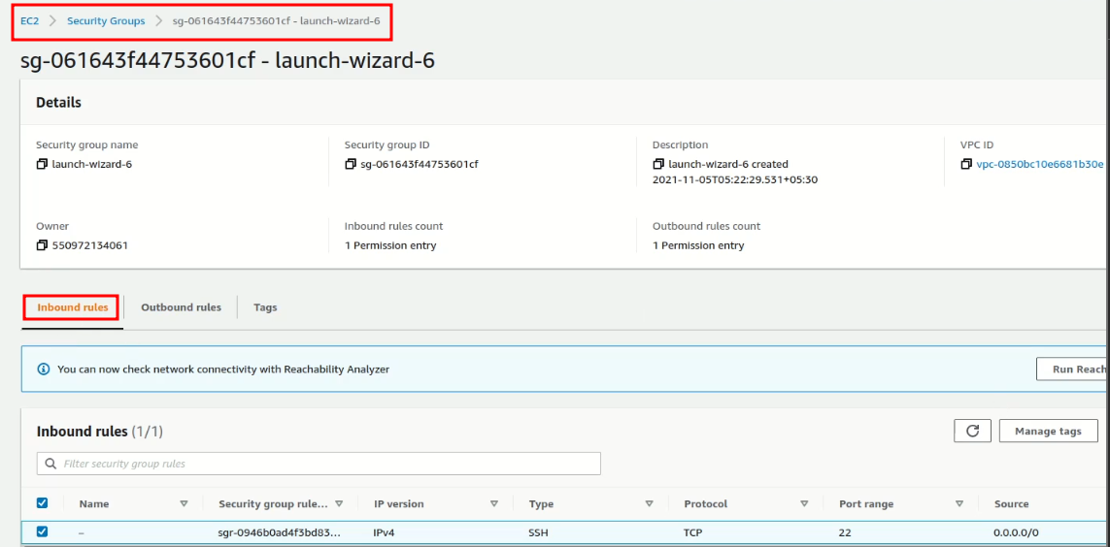
* Edit Inbound Rules (it has the default configuration that if a request is coming “in” it will also allow it to go “out” automatically)
* 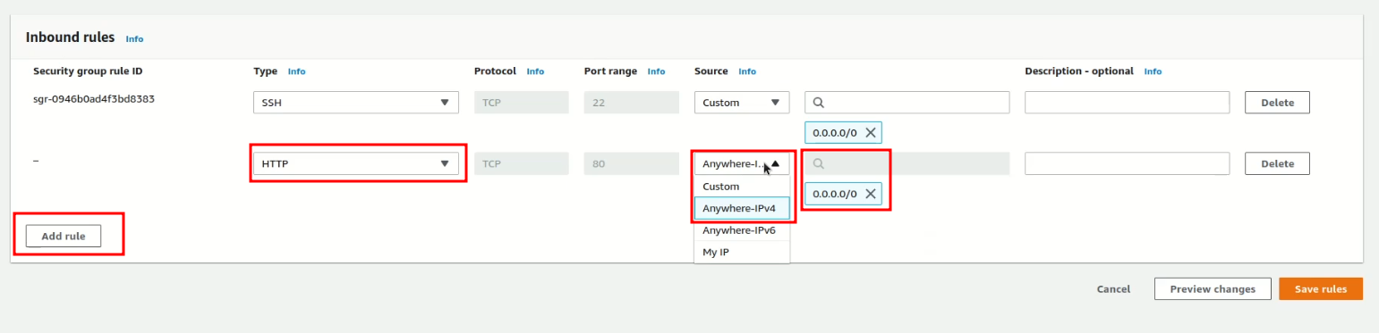
* Save it
* This action is similar to CentOS 6 (IP Tables) and CentOS 7 (firewalld)
* 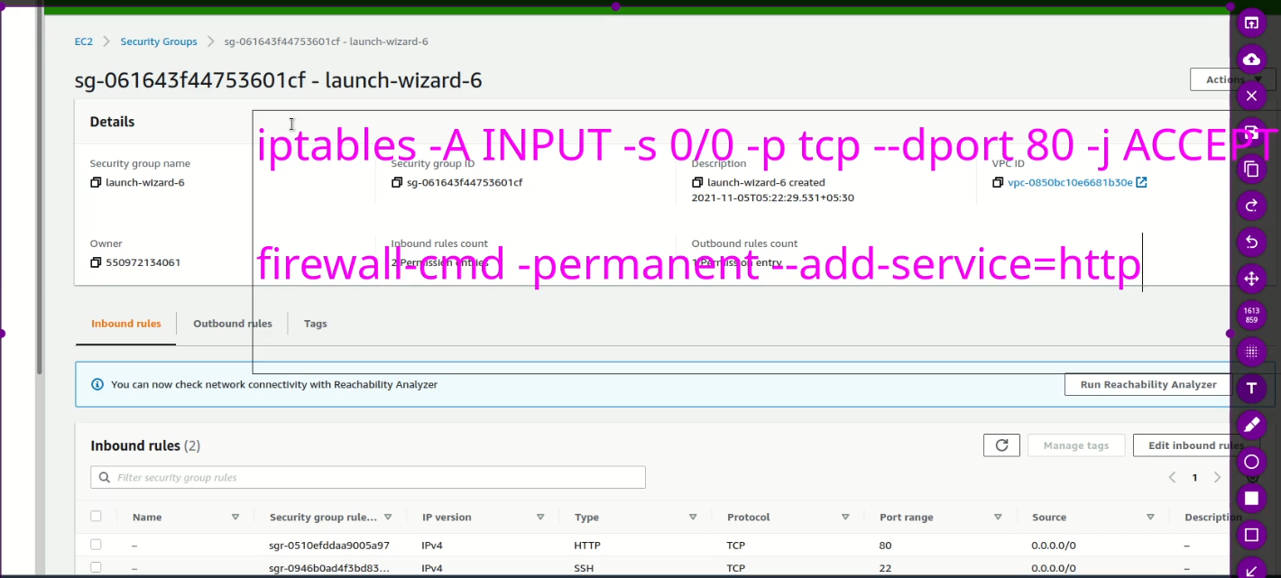
* After completing this step, the telnet is now working.
* 
* Now web site is live globally.
* Graphical user interface, application, Word

  Description automatically generated
* .
* Now setup DNS so that the web page can be accessed from its domain name instead of IP Address.
* Suppose our domain name is registered with godaddy
* 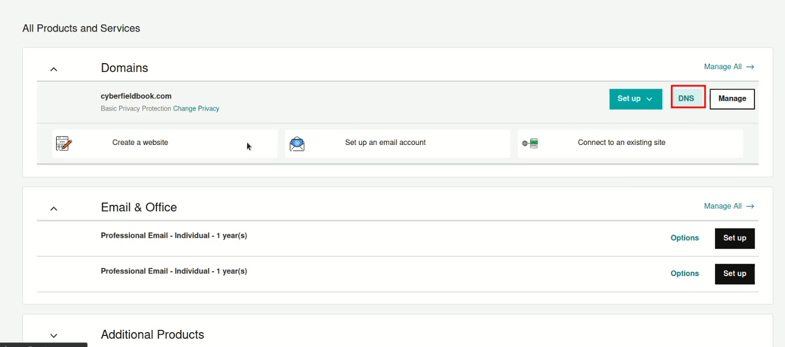
* .
* Graphical user interface, application

  Description automatically generated
* .
* Select domain
* Graphical user interface, application

  Description automatically generated
* .
* We have used similar setting while configuring local DNS.
* 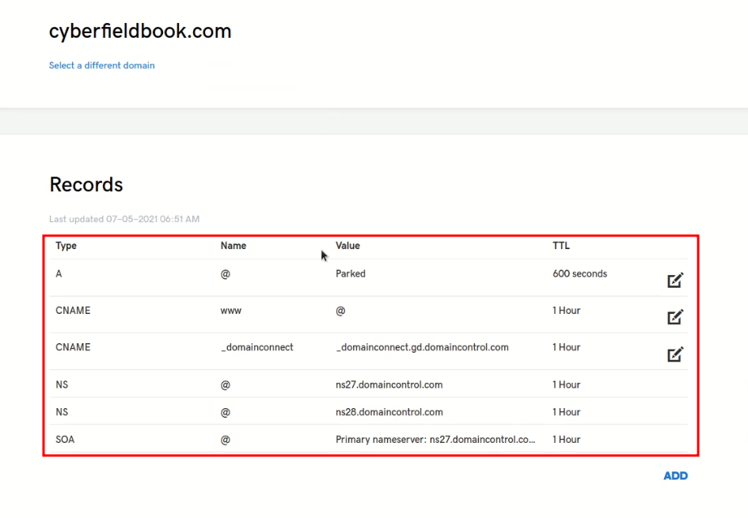
* .
* 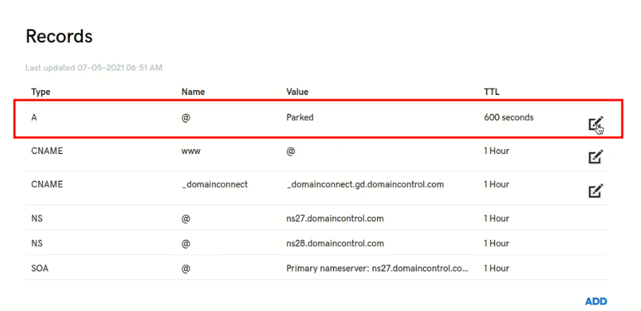
* .
* 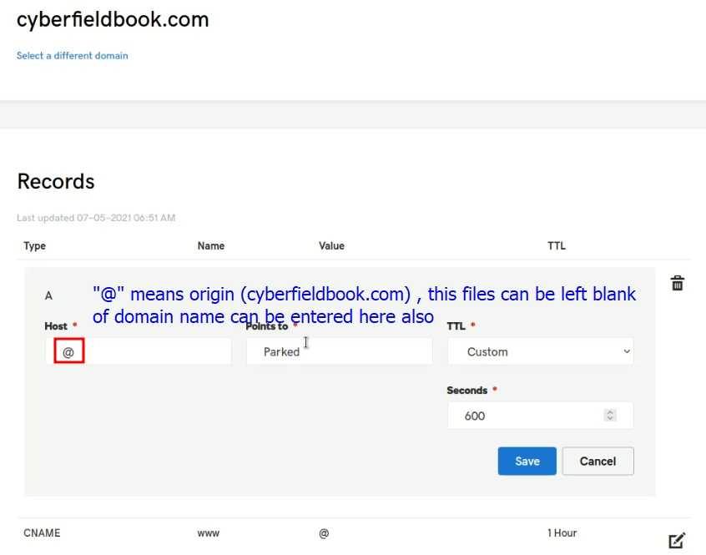
* .
* 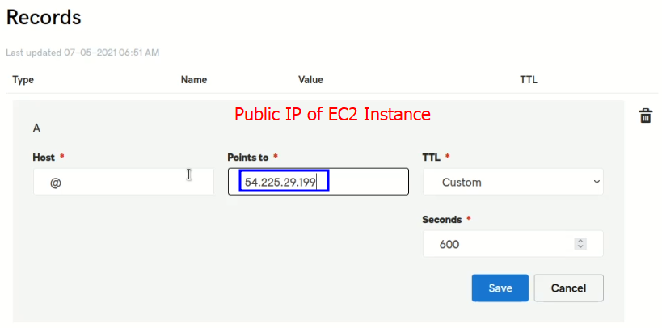.
* Remember if the EC2 Instance is rebooted, this public IP will be changed and these settings will be needed to be changed again accordingly. (Elastic IP is a paid AWS service which provides permanent Public IP)
* Save the settings.
* Note: 2 – 3 hours are required to take the changes get effected.
* 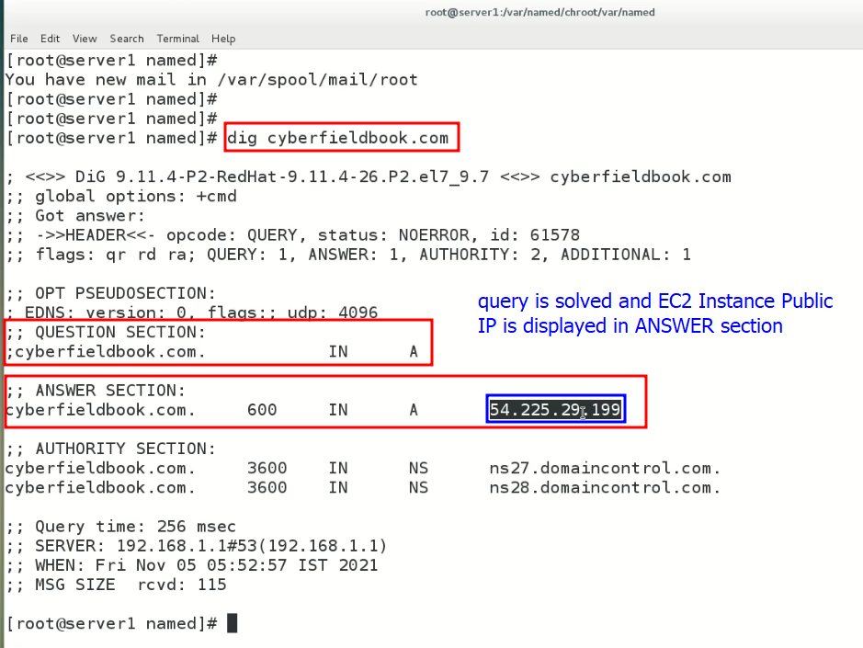
* .
* Web site is working with domain name
* 
 